

**TRAFFIC ACCIDENT DATA ANALYSIS REPORT**

**By Aishwarya Kande**

**Data Analytics Intern at CodEvo Solutions**

**Id: xl7uklin**

**Date: 12/09/2024**

**CONTENTS**

|  |  |  |
| --- | --- | --- |
| S. No | Content | Page no. |
| 1.  2.  3.  4.  5.  6. | About this Report  Methodology  Analytical Tools and Techniques  Visualization and Findings  Recommendations  Conclusion | 3  4  5  6-7  8  9 |

**ABOUT THIS REPORT**

This report, "Traffic Accident Data Analysis," examines Fatality Analysis Reporting Systemto understand the key factors contributing to traffic accidents, including the influence of weather conditions, time of day, geographical locations, and demographic variables, with the goal of identifying patterns and providing recommendations to enhance road safety and reduce accident rates.

**Objective**

The primary objective of this report is to analyse traffic accident data to identify patterns and factors contributing to road accidents. The analysis focuses on understanding the impact of various variables such as weather conditions, time of day, regional hotspots, and demographic factors on the frequency and severity of accidents. The ultimate goal is to provide actionable insights and recommendations to enhance road safety and reduce accident occurrences, especially focusing on areas that show consistent risk patterns.

**Scope**

The scope of this report is limited to the variables available in the datasets, including accident-specific, person-specific, and vehicle-specific information. It does not cover data outside the scope of the available features, such as real-time road monitoring or external factors like economic conditions.

**Significance**

**Data-Driven Decision Making**: It provides critical insights for traffic authorities, urban planners, and policymakers, helping them make data-driven decisions to improve road safety measures.

**Targeted Safety Interventions**: By identifying accident hotspots, at-risk demographic groups, and adverse conditions (e.g., specific weather patterns), the report helps focus resources where they are most needed, maximizing the impact of safety interventions.

**METHODOLOGY**

Data Collection

The dataset was sourced from government website and included extensive records of traffic accident data.

Data Cleaning

Data cleaning is essential for accurate and reliable analysis. The process involves handling missing values by dropping columns with high percentages of missing data to avoid bias, detecting and reviewing outliers in critical variables like fatalities and age for validity, standardizing data by decoding categorical variables encoded as integers to meaningful labels, and converting numeric data such as time of day and accident location into proper formats for easier trend analysis.

Data Organization

To streamline the analysis process, data was organized into logical categories: accident-level data (location, time, weather, fatalities) to identify trends, person-level data (demographics, behavior) joined with accident data via a common identifier (ST_CASE), and vehicle-level data (body type, impact point, driving behavior) to analyze vehicle factors. These datasets were merged using the shared case identifier for comprehensive, multi-dimensional analysis.

Data Importation and Visualization

Data visualization was extensively used to identify trends, correlations, and hotspots. Key visualizations included line and count plots for trend analysis over time, heatmaps for correlation analysis between weather, time, location, and accident severity, injury severity, and restraint use.

Challenges and Solutions

* Missing or Incomplete Data: We addressed missing data by dropping columns with substantial gaps, imputing values where appropriate, and conducting sensitivity analysis for critical variables to assess the impact on results.
* Categorical Encoding: The appropriate documentation to decode encoded columns variables into meaningful labels, ensuring the analysis was interpretable.

**Analytical Tools and Techniques**

In the *Traffic Accident Data Analysis* project, a combination of analytical tools and techniques was employed to effectively process, analyze, and visualize the data. Below is an overview of the methodologies utilized:

**1. Data Collection and Preparation**

* **Data Sources**: The analysis utilized datasets from the Fatality Analysis Reporting System, comprising accident-level, person-level, and vehicle-level data.
* **Data Cleaning**: Initial data cleaning involved handling missing values, correcting inconsistencies, and ensuring data types were appropriately formatted. For instance, columns with significant missing data, such as CENSUS_2020_TRACT_FIPS, were excluded from the analysis to maintain data integrity.

**2. Exploratory Data Analysis (EDA)**

* **Statistical Summaries**: Descriptive statistics, including measures of central tendency and dispersion, were calculated to understand the distribution of key variables like FATALS (fatalities) and A_AGE (age).
* **Visual Exploration**: Histograms and box plots were generated to visualize the distribution of variables, aiding in the identification of outliers and anomalies.

**3. Data Visualization**

* **Trend Analysis**: Line charts and count plots were employed to depict accident trends over time, facilitating the identification of patterns such as seasonal variations or time-of-day effects.
* **Correlation Heatmaps**: Heatmaps were utilized to illustrate the relationship between variables, such as the correlation between weather conditions and accident occurrences, enabling quick visual assessment of associations.

**Visualization and Findings**

1.This visualization suggests that accident prevention strategies should be targeted toward states with high accident counts, focusing on infrastructure improvements and stricter enforcement of traffic laws. States with lower accident counts could benefit from maintaining current policies, but further analysis could reveal specific needs even in low-accident states. 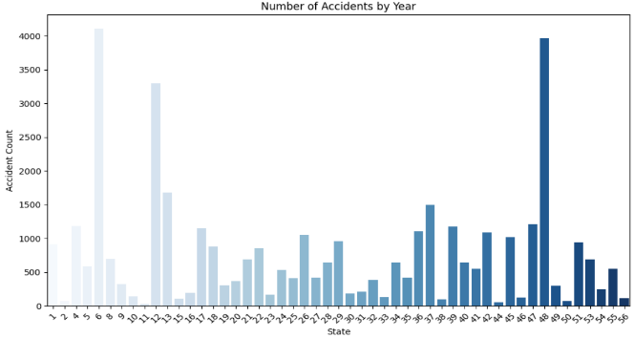

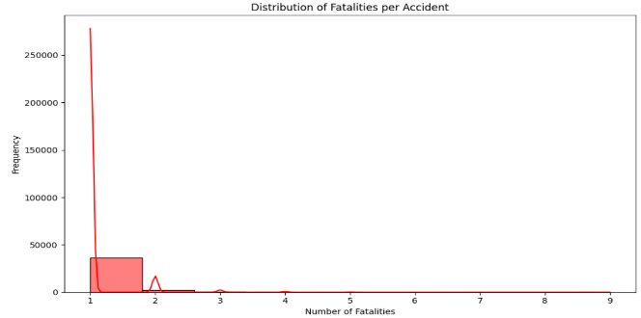2. This analysis suggests that road safety interventions should primarily focus on reducing the likelihood of accidents altogether and mitigating factors that contribute to even single-fatality crashes. Given that multi-fatality accidents are less frequent, strategies focused on broader accident prevention and emergency response improvement may have a more substantial impact on reducing the overall fatality count.

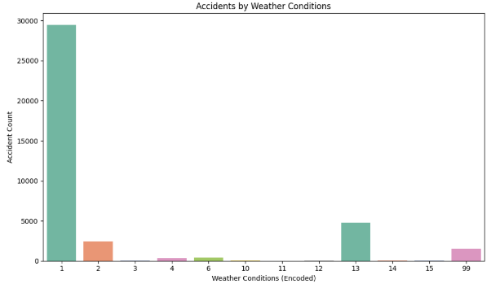3. While adverse weather conditions do contribute to traffic accidents, the data indicates that the majority of accidents occur during clear weather. This suggests that road safety strategies should not only focus on improving safety in adverse weather but also emphasize reducing accidents under normal driving conditions. Driver behaviour, road design, and traffic management could play larger roles in accident prevention.

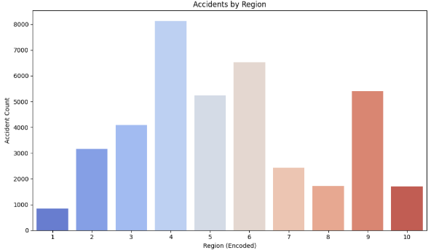4.This is the most accident-prone area, and addressing its road safety challenges should be a priority. Other regions with moderate accident counts can also benefit from enhanced traffic management strategies, while regions with lower counts may serve as models for successful safety measures. Regional differences in accident counts suggest that localized approaches may be more effective than a one-size-fits-all policy.

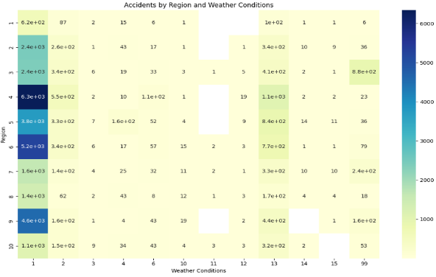 5.It show heightened accident rates under both fair and adverse weather conditions, highlighting them as regions where safety measures (such as driver awareness, traffic control, or infrastructure improvements) could be focused. Weather condition 1 consistently leads to the most accidents across all regions, suggesting that weather is not the primary driver of accidents, and other factors such as traffic management or driver behaviour need more attention.

**Recommendations**

• **Data-Driven Policy Making**: Governments and road safety agencies should utilize data analytics to continuously monitor traffic accidents and assess the effectiveness of safety measures.

• **Public Safety Campaigns**: Increase awareness of the impact of weather, time of day, and driver fatigue on accident risks. Leverage media campaigns to highlight these factors and promote safe driving practices.

• **Technological Investments**: Invest in smart road technologies like variable speed limit signs and weather sensors that can adapt to changing road conditions and automatically inform drivers of hazardous conditions.

• **Driver Education and Legislation**: Periodically update driver education programs to reflect current accident data, focusing on high-risk behaviors and conditions. Strengthen laws related to distracted driving, speeding, and impaired driving.

• **Policy Monitoring**: Road safety measures need to be constantly updated and monitored. New interventions (e.g., stricter enforcement of traffic laws, awareness campaigns) should be regularly introduced and tested to decrease accident rates over time.

• **Yearly Evaluations**: Implement yearly evaluations of traffic safety interventions and policies to identify which ones lead to reductions in accident counts.

• **Focus on High-Fatality Accident Prevention**: Investigate and address the factors contributing to the rare but highly fatal accidents. These may include high-speed collisions, lack of seatbelt use, or insufficient infrastructure.

• **Public Awareness Campaigns**: Continue to promote the importance of seatbelt use and safe driving, especially targeting high-risk behaviors such as speeding or drunk driving.

**Conclusion**

The analysis of traffic accident data from the Fatality Analysis Reporting System provides crucial insights into the factors contributing to road accidents and fatalities. Through a combination of exploratory data analysis, statistical techniques, and data visualizations, key patterns were identified that can help inform policies and strategies to enhance road safety.

The findings revealed that weather conditions, time of day, and geographic location play significant roles in the occurrence and severity of accidents. Adverse weather, such as rain, snow, and fog, correlates with a higher frequency of accidents, highlighting the need for weather-specific safety interventions. Accidents were also shown to peak during specific times of the day, particularly early morning and late at night, when visibility and driver fatigue may be contributing factors.

Geographical analysis pinpointed certain regions with higher accident densities, suggesting that targeted infrastructure improvements and stricter enforcement of traffic laws in these hotspots could significantly reduce accident rates. Additionally, demographic factors such as age and driver behavior (e.g., alcohol involvement or seatbelt use) emerged as critical elements affecting the severity of accidents.

In summary, this analysis demonstrates the importance of data-driven decision-making in traffic management and road safety. By understanding the variables that contribute to traffic accidents, policymakers, law enforcement agencies, and urban planners can implement more focused and effective safety measures. Continued monitoring of traffic data and the adoption of preventive strategies, such as enhanced public awareness campaigns, improved road design, and stricter law enforcement during high-risk periods, will be essential in reducing traffic-related injuries and fatalities.

This report provides a foundation for further research and analysis, potentially incorporating predictive models to proactively identify high-risk scenarios and mitigate accident risks before they occur. The recommendations from this study, if implemented, can make a meaningful contribution to reducing road accidents and enhancing overall road safety.